Low-Level Design (LLD) — Products Module
Attribute | Value
Module | Products (Product Master Administration)
Menu path | SYSTEM CONFIGURATION → Products
Landing page | products.php
Application | Complaint / Dealer Portal
Stack (target) | Core PHP + MySQL (PDO)
Stack (current repo) | Core PHP + PostgreSQL via PDO
Document version | 1.0
Access | System Admin only (role id 6) — no RBAC module slug

â”€â”€â”€â”€â”€â”€â”€â”€â”€â”€â”€â”€â”€â”€â”€â”€â”€â”€â”€â”€â”€â”€â”€â”€â”€â”€â”€â”€â”€â”€â”€â”€

1. Module Overview

1.1 Purpose
System Administrators maintain the product catalog in product_master_vayu: create and edit product rows (DPST, TPL code/description, pricing, validity, warehouse, company, order type), list/filter via DataTables, view details, and hard-delete products. Downstream modules (order booking, machine-model helpers) resolve products by tplcode (and often order_type / dpst), not by admin UI id.

1.2 Scope
In scope | Out of scope
List / Add / Edit / Details / Delete | Spare Parts Consumption capture
Valid (Y/N) list filter | Soft-delete lifecycle
TPL Code + Order Type uniqueness | Select2 (native selects used)
Create abuse / rate-limit guard | Order booking product search UX
Y/N flags (TOD, Excisable, Valid) | RBAC module-slug gating

1.3 High-level architecture
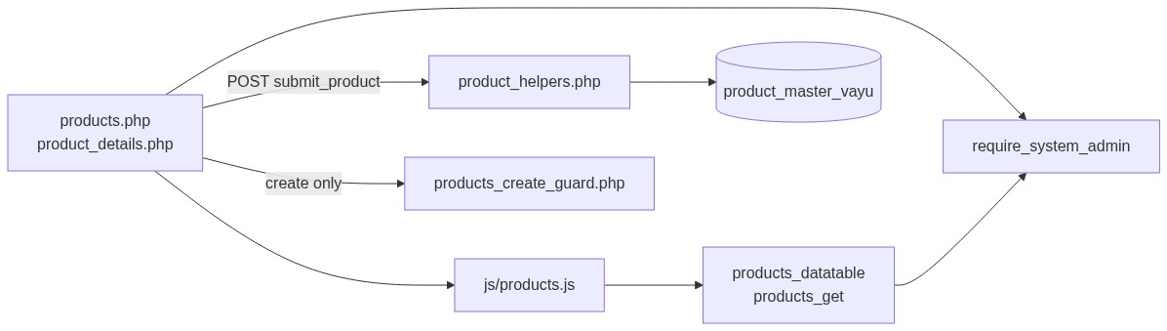
Figure 1 — High-level architecture
â”€â”€â”€â”€â”€â”€â”€â”€â”€â”€â”€â”€â”€â”€â”€â”€â”€â”€â”€â”€â”€â”€â”€â”€â”€â”€â”€â”€â”€â”€â”€â”€

2. Functional Requirements
ID | Requirement | Priority
FR-01 | System Admin can open Products list (DataTables) | Must
FR-02 | Create product with required catalog and pricing fields | Must
FR-03 | Edit product via inline slide-down form | Must
FR-04 | Hard-delete product with client confirm | Must
FR-05 | Unique tplcode per order_type (case-insensitive) | Must
FR-06 | Filter list by Valid (Y/N) | Should
FR-07 | View read-only product details | Should
FR-08 | Throttle / rate-limit create requests | Should
FR-09 | Client validate.js constraints + numeric input filters | Should
FR-10 | Load product for edit via JSON get API | Must

â”€â”€â”€â”€â”€â”€â”€â”€â”€â”€â”€â”€â”€â”€â”€â”€â”€â”€â”€â”€â”€â”€â”€â”€â”€â”€â”€â”€â”€â”€â”€â”€

3. User Roles & Permissions

3.1 RBAC module slug
None. Products administration is gated by System Admin (SYSTEM_ADMIN_ROLE = 6), not a permission slug.

3.2 Permission matrix
Capability | Gate
All Products pages | require_system_admin($obconn)
Products APIs | admin_api_require_system_admin
Denied | Access denied. System Admin privileges required.

Admin pages (products.php, product_details.php, delete_product.php) are listed in rbac_admin_pages() and skip module RBAC; System Admin check is authoritative.

3.3 Page / API mapping
Resource | Gate
products.php | System Admin
product_details.php | System Admin
delete_product.php | System Admin
api/products_datatable.php | System Admin API
api/products_get.php | System Admin API

3.4 After-market list scope
N/A for Products admin UI. Product rows are consumed elsewhere by tplcode / order_type / dpst lookups.
â”€â”€â”€â”€â”€â”€â”€â”€â”€â”€â”€â”€â”€â”€â”€â”€â”€â”€â”€â”€â”€â”€â”€â”€â”€â”€â”€â”€â”€â”€â”€â”€

4. Business Rules
ID | Rule
BR-01 | Uniqueness: LOWER(TRIM(tplcode)) + order_type among all rows (edit excludes self).
BR-02 | Order type values: 1 = Units, 2 = Spares.
BR-03 | valid is required Y/N; used as list filter, not soft-delete.
BR-04 | tod_flag / excisable default to N when blank on bind.
BR-05 | Empty dealer_price binds as '0'; empty otcode binds as NULL.
BR-06 | Optional numerics mc / vc / fc may be blank; cos is required numeric.
BR-07 | Insert sets status = '1'; update does not change status; delete does not flip status.
BR-08 | Delete is hard DELETE FROM product_master_vayu (no deleted_at).
BR-09 | Create-only abuse guard: max 1 record/request; min 3s interval; max 20 creates / 15 min.
BR-10 | Edit requires existing row; otherwise Product not found or already deleted.
BR-11 | updated_by = current username (max 30); updated_date = CURRENT_TIMESTAMP.
BR-12 | Details/delete URL ids are base64_encode((string) id).
BR-13 | No DB FK cascade in app; consumers reference by tplcode (orphan risk on delete).
BR-14 | Create/update stay on page (no PRG redirect). Delete redirects to products.php.

â”€â”€â”€â”€â”€â”€â”€â”€â”€â”€â”€â”€â”€â”€â”€â”€â”€â”€â”€â”€â”€â”€â”€â”€â”€â”€â”€â”€â”€â”€â”€â”€

5. Database Design

5.1 ER diagram
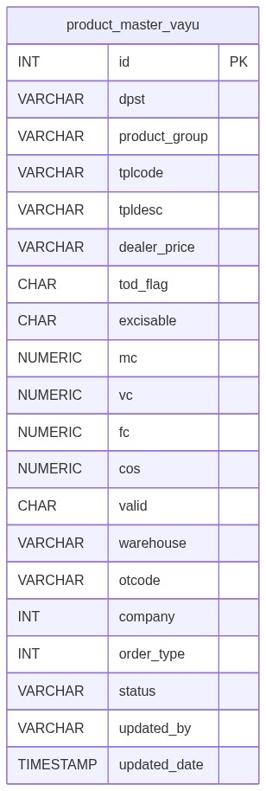
Figure 2 — Entity relationship diagram
Logical consumers (not FK-enforced in this module):
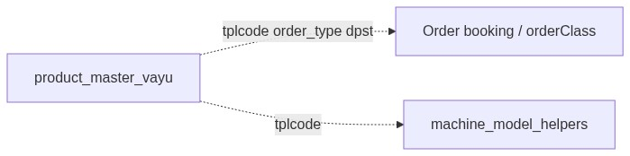
Figure 3 — Consumer relationships

5.2 Table: product_master_vayu
Column | MySQL type | Notes
id | INT UNSIGNED AUTO_INCREMENT | PK
dpst | VARCHAR(10) | Required
product_group | VARCHAR(50) | Required
tplcode | VARCHAR(20) | Unique with order_type
tpldesc | VARCHAR(60) | Required
dealer_price | VARCHAR(7) | Empty → '0'
tod_flag | CHAR(1) | Y/N; default N
excisable | CHAR(1) | Y/N; default N
mc / vc / fc | DECIMAL NULL | Optional
cos | DECIMAL | Required price
valid | CHAR(1) | Y/N required
warehouse | VARCHAR(3) | Required
otcode | VARCHAR(3) NULL | Optional
company | INT | Required integer
order_type | INT | 1 Units / 2 Spares
status | VARCHAR | Insert '1' only
updated_by | VARCHAR(30) | Last editor
updated_date | TIMESTAMP | Last change

5.3 Related tables
Table / consumer | Role
Order booking classes | Resolve products by tplcode / order type
machine_model_helpers | Model/product lookups

5.4 Reference / lookup sources
Source | Usage
product_yn_options() | TOD / Excisable / Valid selects
product_order_type_options() | Units / Spares
Valid filter (valid_filter) | DataTable ajax reload

â”€â”€â”€â”€â”€â”€â”€â”€â”€â”€â”€â”€â”€â”€â”€â”€â”€â”€â”€â”€â”€â”€â”€â”€â”€â”€â”€â”€â”€â”€â”€â”€

6. API / Backend Design

6.1 Page endpoints
Endpoint | Method | Auth | Description
products.php | GET | System Admin | List + Add/Edit panel
products.php | POST submit_product | System Admin | Create or update
product_details.php?id= | GET | System Admin | Read-only details
delete_product.php?id= | GET | System Admin | Hard delete

6.2 JSON APIs

POST api/products_datatable.php
DataTables server-side. Optional valid_filter = Y / N. Search across catalog fields via product_search_filter / rbac_search_filter.
{
"draw": 1,
"recordsTotal": 100,
"recordsFiltered": 12,
"data": [{ "id": "#1", "tplcode": "...", "actions": "<html>" }]
}

GET api/products_get.php?id=
Returns product fields for edit form population. System Admin API gated.

6.3 Supporting lookup APIs
N/A (Y/N and order-type options rendered server-side).

6.4 Core PHP responsibilities
File | Role
includes/product_helpers.php | from_post, validate, CRUD, bind, display, actions
includes/module_create_guards/products_create_guard.php | Create throttle / rate limit / abuse log
includes/admin_access_helpers.php | System Admin gate
includes/admin_api_guard.php | System Admin API gate
includes/record_details_layout.php | Details page layout helpers

â”€â”€â”€â”€â”€â”€â”€â”€â”€â”€â”€â”€â”€â”€â”€â”€â”€â”€â”€â”€â”€â”€â”€â”€â”€â”€â”€â”€â”€â”€â”€â”€

7. Validation Rules

7.1 Server-side (product_validate + uniqueness + create guard)
Field / rule | Message
DPST | Required; max 10
Product Group | Required; max 50
TPL Code | Required; max 20
TPL Description | Required; max 60
Dealer Price | Numeric if set; max 7
TOD Flag / Excisable | Y or N if set
MC / VC / FC | Numeric if set
COS | Required; numeric
Valid | Required; Y or N
Warehouse | Required; max 3
OT Code | Max 3
Company | Required; integer
Order Type | Required; Units or Spares
Unique TPL | TPL Code already exists for this Order Type...
Create throttle | Please wait a few seconds... / rate-limit messages

7.2 Client-side (js/products.js)
â€¢ validate.js constraints aligned with server lengths/required fields
â€¢ Numeric-only key/paste filters for dealer_price, mc, vc, fc, cos
â€¢ Form novalidate; JS owns validation
â€¢ tod_flag / excisable not constrained by validate.js (select defaults)
â”€â”€â”€â”€â”€â”€â”€â”€â”€â”€â”€â”€â”€â”€â”€â”€â”€â”€â”€â”€â”€â”€â”€â”€â”€â”€â”€â”€â”€â”€â”€â”€

8. UI Screen Specifications

8.1 Listing — products.php
Element | Spec
Subtitle | Manage product master records. (or equivalent page header)
CTA | Add Product / Cancel
Filter | Valid (All / Y / N)
Grid | Catalog columns + Valid + Order Type + Actions
Actions | View / Edit / Delete
Empty | DataTables empty / no-match messages

8.2 Form panel
Slide-down #productFormCard fields: DPST*, Product Group*, TPL Code*, TPL Description*, Dealer Price, TOD Flag, Excisable, MC, VC, FC, COS*, Valid*, Warehouse*, OT Code, Company*, Order Type*.
Hidden: record_id, submit_product.

8.3 Details — product_details.php
Read-only sections via record_details_* helpers; Y/N badges for flags/valid; order-type label.

8.4 Modals
None for CRUD. Delete uses browser confirm(...). Edit loads via products_get into the same form panel.
â”€â”€â”€â”€â”€â”€â”€â”€â”€â”€â”€â”€â”€â”€â”€â”€â”€â”€â”€â”€â”€â”€â”€â”€â”€â”€â”€â”€â”€â”€â”€â”€

9. Database Flow

9.1 Create
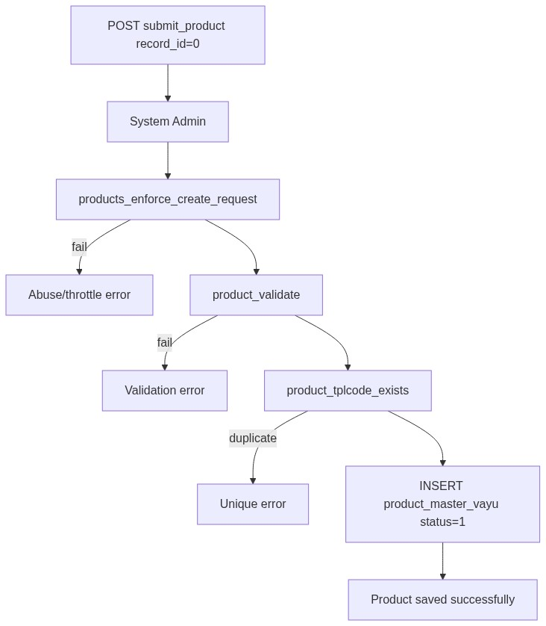
Figure 4 — Create database flow

9.2 Hard delete
DELETE FROM product_master_vayu
WHERE id = :id;

9.3 List query pattern
SELECT *
FROM product_master_vayu
WHERE /* optional valid = :valid_filter */
AND /* optional search ILIKE across fields */
ORDER BY id DESC
LIMIT :limit OFFSET :offset;
â”€â”€â”€â”€â”€â”€â”€â”€â”€â”€â”€â”€â”€â”€â”€â”€â”€â”€â”€â”€â”€â”€â”€â”€â”€â”€â”€â”€â”€â”€â”€â”€

10. Sequence Diagram

10.1 Create product
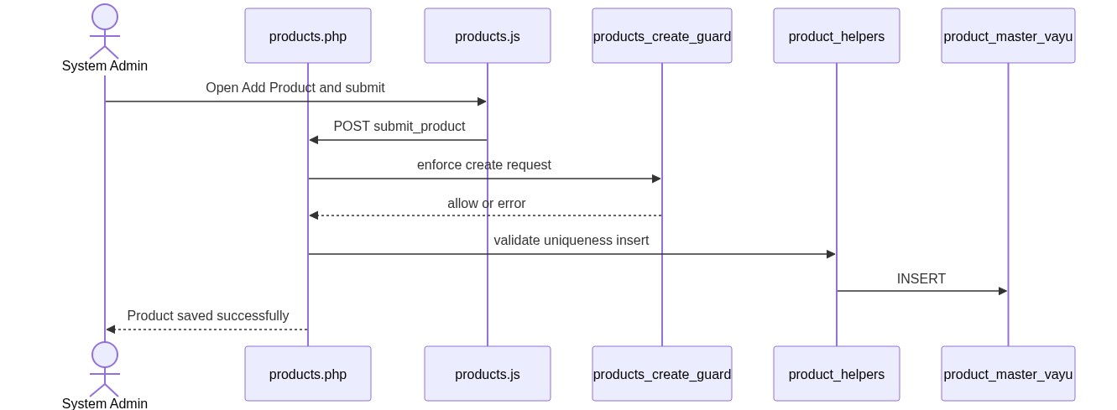
Figure 5 — Sequence: Create product

10.2 Edit product
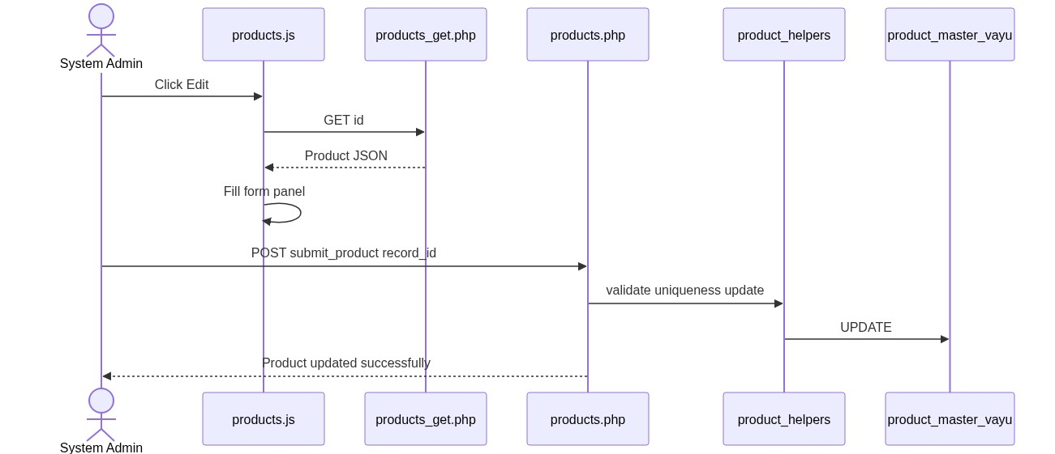
Figure 6 — Sequence: Edit product
â”€â”€â”€â”€â”€â”€â”€â”€â”€â”€â”€â”€â”€â”€â”€â”€â”€â”€â”€â”€â”€â”€â”€â”€â”€â”€â”€â”€â”€â”€â”€â”€

11. Activity Diagram
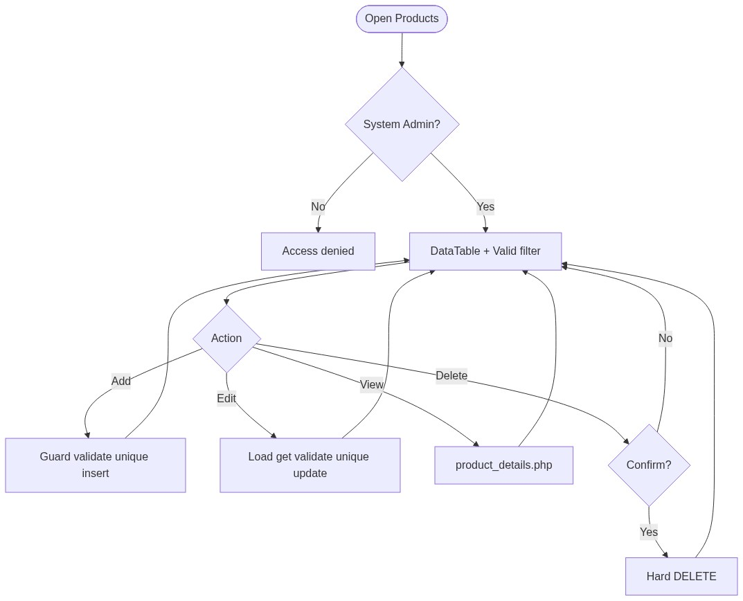
Figure 7 — Activity diagram
â”€â”€â”€â”€â”€â”€â”€â”€â”€â”€â”€â”€â”€â”€â”€â”€â”€â”€â”€â”€â”€â”€â”€â”€â”€â”€â”€â”€â”€â”€â”€â”€

12. Class / Module Diagram
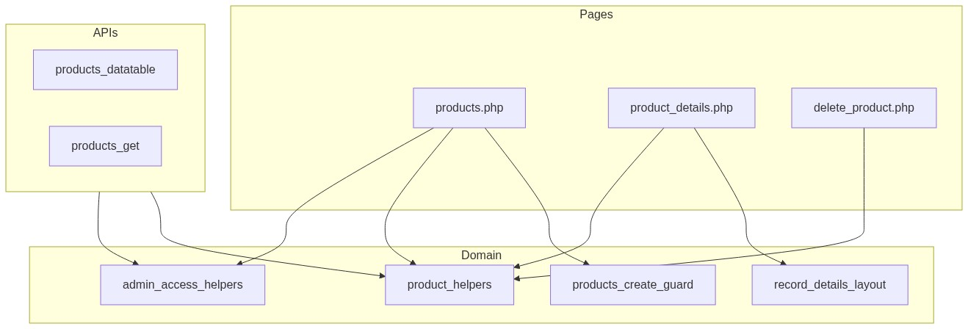
Figure 8 — Class / module diagram

12.1 Key functions
Function | Role
product_from_post / product_validate | Parse + validate
product_tplcode_exists | Uniqueness
product_insert / product_update / product_delete | Persist
product_bind_common | Shared PDO binds
product_get_by_id | Load row
product_entry_actions | View / Edit / Delete HTML
product_yn_* / product_order_type_* | Options / labels / badges
products_enforce_create_request | Create abuse guard
require_system_admin | Access gate

â”€â”€â”€â”€â”€â”€â”€â”€â”€â”€â”€â”€â”€â”€â”€â”€â”€â”€â”€â”€â”€â”€â”€â”€â”€â”€â”€â”€â”€â”€â”€â”€

13. Folder Structure
ComplaintManagement/
├── products.php
├── product_details.php
├── delete_product.php
├── api/
│ ├── products_datatable.php
│ └── products_get.php
├── includes/
│ ├── product_helpers.php
│ ├── admin_access_helpers.php
│ ├── admin_api_guard.php
│ ├── record_details_layout.php
│ └── module_create_guards/
│ └── products_create_guard.php
├── js/
│ └── products.js
├── storage/
│ └── request_abuse/products/
└── docs/
└── LLD_Products_Module.md
â”€â”€â”€â”€â”€â”€â”€â”€â”€â”€â”€â”€â”€â”€â”€â”€â”€â”€â”€â”€â”€â”€â”€â”€â”€â”€â”€â”€â”€â”€â”€â”€

14. Error Handling
Layer | Pattern
Page POST | Local $error_message / $success_message
Delete | Session flash → products.php
Details invalid | die('Invalid record.') / die('Product not found.')
APIs | JSON + HTTP 403/404 as applicable
Create guard | Inline error + abuse log under storage/request_abuse/products/

14.1 Common messages
Message | When
Product saved successfully. | Create
Product updated successfully. | Update
Product deleted successfully. | Hard delete (session flash)
Failed to save product. / Failed to update product. | Persist fail
Product not found or already deleted. | Missing edit target
TPL Code already exists for this Order Type... | Unique violation
Please wait a few seconds before creating another record. | Min interval
Create rate limit exceeded... | 20 / 15 min
Access denied. System Admin privileges required. | Non-admin

â”€â”€â”€â”€â”€â”€â”€â”€â”€â”€â”€â”€â”€â”€â”€â”€â”€â”€â”€â”€â”€â”€â”€â”€â”€â”€â”€â”€â”€â”€â”€â”€

15. Security Considerations
Area | Control
Authorization | System Admin hard-gate on pages + APIs
Create abuse | Throttle, rate limit, payload size, monitor log
XSS | Escaped alerts / table actions / details
CSRF | Not implemented on POST or GET delete
Delete method | GET delete — CSRF-friendly; confirm only
PRG | Not used on create/update — refresh may re-POST
Uniqueness | App-level only; race without DB UNIQUE
Hard delete | No referential check against order/booking consumers
Id encoding | Base64 obfuscation only; authz is admin gate
Gaps | status unused as lifecycle; empty-usr_name API check commented in guard

â”€â”€â”€â”€â”€â”€â”€â”€â”€â”€â”€â”€â”€â”€â”€â”€â”€â”€â”€â”€â”€â”€â”€â”€â”€â”€â”€â”€â”€â”€â”€â”€

16. Audit Logs

16.1 Built-in field-level audit
Field | Behavior
updated_by / updated_date | On insert and update
status | Set '1' on insert only
Dedicated audit table | Not implemented
Create abuse log | storage/request_abuse/products/abuse_monitor.log

â”€â”€â”€â”€â”€â”€â”€â”€â”€â”€â”€â”€â”€â”€â”€â”€â”€â”€â”€â”€â”€â”€â”€â”€â”€â”€â”€â”€â”€â”€â”€â”€

17. Test Cases

17.1 Functional
ID | Scenario | Expected
TC-01 | Non-admin opens Products | Denied
TC-02 | Create with missing COS | Validation error
TC-03 | Create duplicate tplcode + same order_type | Rejected
TC-04 | Create same tplcode different order_type | Allowed
TC-05 | Edit change tplcode to existing pair | Rejected
TC-06 | Valid filter = N | Only invalid rows
TC-07 | Edit via pencil | Form filled from products_get
TC-08 | Delete confirmed | Row removed; flash success
TC-09 | Create twice within 3 seconds | Throttle error
TC-10 | Create >20 in 15 minutes | Rate-limit error
TC-11 | Details with bad base64 id | Invalid record
TC-12 | Order type Spares label | Displays Spares

â”€â”€â”€â”€â”€â”€â”€â”€â”€â”€â”€â”€â”€â”€â”€â”€â”€â”€â”€â”€â”€â”€â”€â”€â”€â”€â”€â”€â”€â”€â”€â”€

18. Assumptions & Dependencies

18.1 Assumptions
1. Role id 6 is System Admin.
2. product_master_vayu is the canonical product catalog for the portal.
3. Downstream modules look up by tplcode / order_type / dpst, not admin soft-delete semantics.
4. Hard delete is acceptable operationally (or callers tolerate missing products).
5. Document target stack Core PHP + MySQL; repo runs PostgreSQL.
6. App-level uniqueness is sufficient unless a DB UNIQUE constraint is added later.

18.2 Dependencies
Dependency | Purpose
admin_access_helpers / admin_api_guard | System Admin gate
record_details_layout | Details presentation
Create-guard storage dir | Throttle state + abuse log
jQuery + DataTables + validate.js | List / form UX
Bootstrap 5 | Alerts / layout

â”€â”€â”€â”€â”€â”€â”€â”€â”€â”€â”€â”€â”€â”€â”€â”€â”€â”€â”€â”€â”€â”€â”€â”€â”€â”€â”€â”€â”€â”€â”€â”€

Appendix A — Success flashes
Event | Message
Create | Product saved successfully.
Update | Product updated successfully.
Delete | Product deleted successfully.

â”€â”€â”€â”€â”€â”€â”€â”€â”€â”€â”€â”€â”€â”€â”€â”€â”€â”€â”€â”€â”€â”€â”€â”€â”€â”€â”€â”€â”€â”€â”€â”€

Appendix B — Select2 control map
N/A. Valid filter, TOD Flag, Excisable, Valid, and Order Type use native HTML selects.
â”€â”€â”€â”€â”€â”€â”€â”€â”€â”€â”€â”€â”€â”€â”€â”€â”€â”€â”€â”€â”€â”€â”€â”€â”€â”€â”€â”€â”€â”€â”€â”€

Appendix C — Order type reference
Value | Label
1 | Units
2 | Spares

â”€â”€â”€â”€â”€â”€â”€â”€â”€â”€â”€â”€â”€â”€â”€â”€â”€â”€â”€â”€â”€â”€â”€â”€â”€â”€â”€â”€â”€â”€â”€â”€

Appendix D — Create guard limits
Limit | Value
Max records per request | 1
Min interval between creates | 3 seconds
Max creates per window | 20
Window | 15 minutes

â”€â”€â”€â”€â”€â”€â”€â”€â”€â”€â”€â”€â”€â”€â”€â”€â”€â”€â”€â”€â”€â”€â”€â”€â”€â”€â”€â”€â”€â”€â”€â”€
End of LLD — Products Module

